**Different type of Distance Measures:**

**1) Euclidean distance or L2 Norm:**

Euclidean distance is calculated as mentioned in below image.

**Note**: difference between Norm and Metric(distance between two points)

A norm and a metric are two related but different things. Generally speaking, a norm is a more "vector space" concept than metrics.

A norm assigns value to a **SINGLE** vectors (its length) in a vector space, while metric assigns value to **TWO** elements (their distance) in a metric space (which is not necessarily a vector space). Of course, in a vector space, a metric system can always be induced from a norm system by defining ||x-y|| as d(x,y).

Here d is the metric here which is length of shortest line from x1 to x2.

And ||x1 – x2||2 is L2 Norm of vector x1-x2

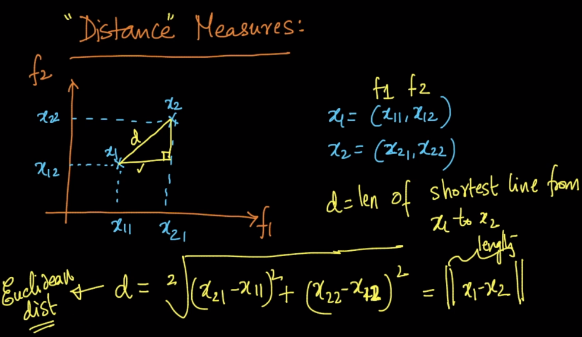

Similarly for only 1 point, it’s Euclidian distance is calculated as given in below figure which is also equal to L2 norm of vector x1.

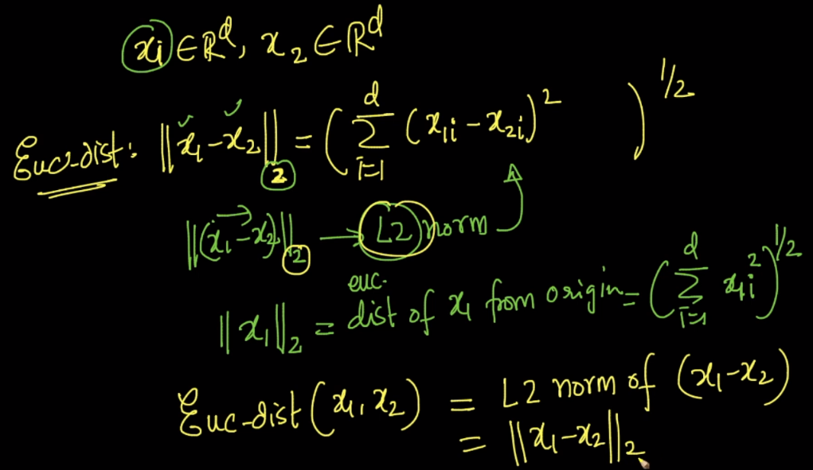

**2) Manhattan distance or L1****Norm:**

Also known as Manhattan Distance or Taxicab norm. L1 Norm is the sum of the magnitudes of the vectors in a space. It is the most natural way of measure distance between vectors, that is the sum of absolute difference of the components of the vectors. In this norm, all the components of the vector are weighted equally.

Having, for example, the vector X = [3,4]:

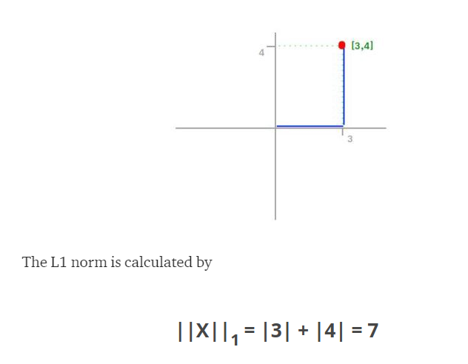

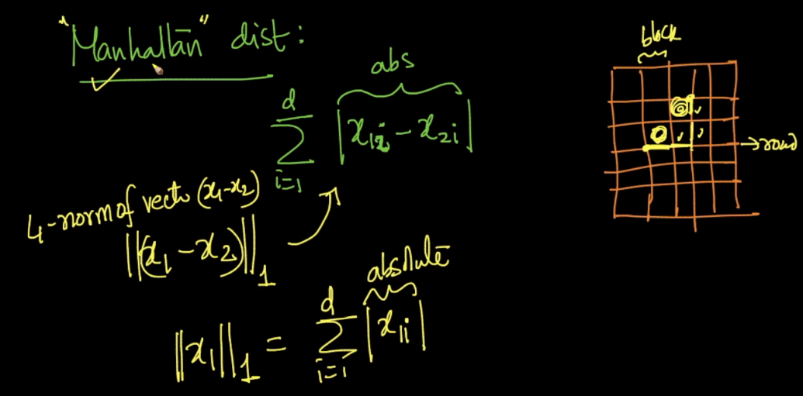

Manhattan distance between two points (x1, x2) = L1 Norm of vector of x1-x2.

**3) Lp-norms or Minkowski distance:**

It can be called as generalization of L1, L2, L3, ….. Ln Norms, and it’s described as given in below fig.

Here p != 0 and p > 0.

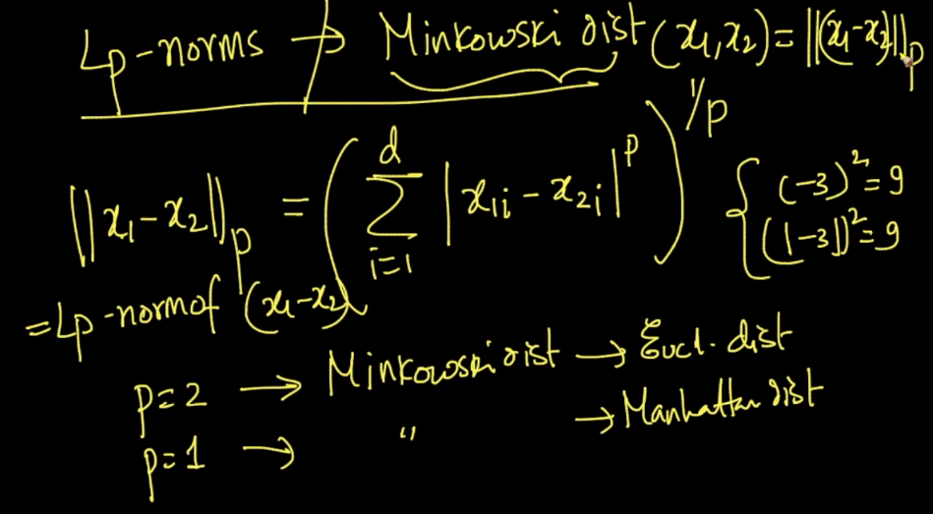

Similarly Lp norm for a vector with single point x1.

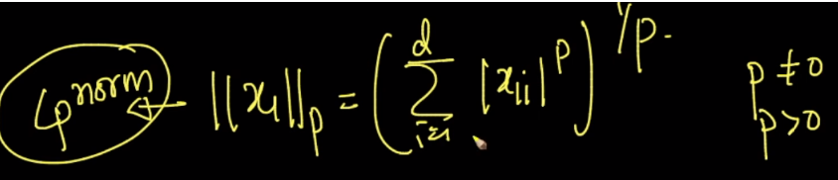

**4) Hamming distance:**

[Hamming Distance](https://www.geeksforgeeks.org/hamming-distance-two-strings/) between two integers is the number of bits which are different at same position in both numbers.

And for string it is the number of positions at which the corresponding [symbols](https://en.wikipedia.org/wiki/Symbol) are different.

Hamming distance is generally used when we’ve to find distance between Boolean vectors (like binary BOW), or distance between two strings (like find distance to determine similarity of two Gene sequence).

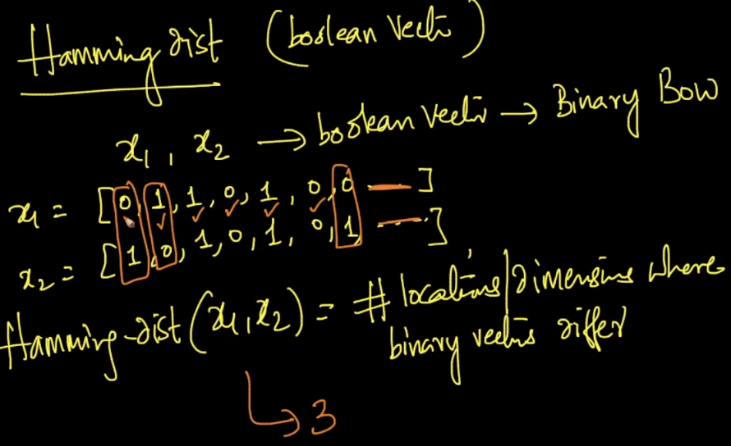

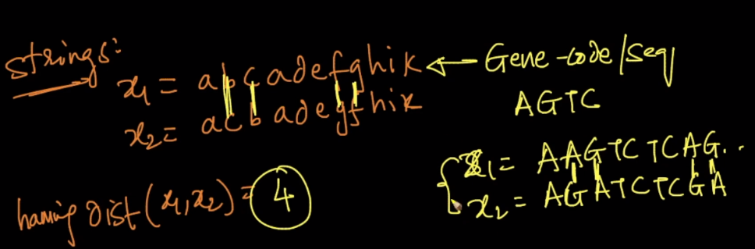

Note:

* Euclidean is a good distance measure to use if the input variables are similar in type (e.g. all measured widths and heights). Manhattan distance is a good measure to use if the input variables are not similar in type (such as age, gender, height, etc.).
* In case if our problem needs computing the geometric distances between the points, then we need to go for euclidean distance measure.
* In case if our problem needs computing the angular distances between the points(ignoring the geometrical distances), then we need to go for cosine distance measure.
* In case if our problem needs computing the distances between the points in the form of grid, then we need to go for manhattan distance measure.